|  |  |
| --- | --- |
| COURSE MATERIAL | |
| SUBJECT | **ELECTRICAL MEASUREMENTS (15A02501)** |
| UNIT | **2** |
| COURSE | **B.TECH** |
| DEPARTMENT | **ELECTRICAL AND ELECTRONICS** |
| SEMESTER | **31** |
| PREPARED BY  (Faculty Name/s) | **Mrs. R.SIREESHA**  **Assistant Professor** |
| Version | **V-1** |
| PREPARED / REVISED DATE | **15-12-2020** |

|  |  |  |  |
| --- | --- | --- | --- |
| TABLE OF CONTENTS – UNIT 2 | | | |
| S. NO | **CONTENTS** | | **PAGE NO.** |
| 1 | **COURSE OBJECTIVES** | | **1** |
| 2 | **PREREQUISITES** | | **1** |
| 3 | **SYLLABUS** | | **1** |
| 4 | **COURSE OUTCOMES** | | **1** |
| 5 | **CO - PO/PSO MAPPING** | | **1** |
| 6 | **LESSON PLAN** | | **2** |
| 7 | **ACTIVITY BASED LEARNING** | | **2** |
| 8 | **LECTURE NOTES** | | **2** |
|  | **2.1** | **INTRODUCTION** | **2** |
|  | **2.2** | **MEASUREMENT OF LOW RESISTANCE** | **3** |
|  | **2.2.1** | **KELVIN’S DOUBLE BRIDGE** | **3** |
|  | **2.3** | **MEASUREMENT OF MEDIUM RESISTANCE** | **4** |
|  | **2.3.1** | **WHEATSTONE BRIDGE** | **4** |
|  | **2.4** | **MEASUREMENT OF HIGH RESISTANCE** | **5** |
|  | **2.4.1** | **LOSS OF CHARGE METHOD** | **5** |
|  | **2.5** | **GENERAL FORM OF A.C. BRIDGE:** | **6** |
|  | **2.6** | **MAXWELL’S INDUCTANCE BRIDGE** | **9** |
|  | **2.7** | **MAXWELL’S INDUCTANCE CAPACITANCE BRIDGE** | **11** |
|  | **2.8** | **HAY’S BRIDGE & OWEN’S BRIDGE** | **13** |
|  | **2.9** | **ANDERSON’S BRIDGE** | **17** |
|  | **2.10** | **MEASUREMENT OF CAPACITANCE AND LOSS ANGLE (DISSIPATION FACTOR) DESAUTY’S BRIDGE** | **21** |
|  | **2.11** | **SCHERING BRIDGE** | **23** |
|  | **2.12** | **MEASUREMENTS OF FREQUENCY-WEIN'S BRIDGE** | **26** |
| 9 | **PRACTICE QUIZ** | | **28** |
| 10 | **ASSIGNMENTS** | | **31** |
| 11 | **PART A QUESTIONS & ANSWERS (2 MARKS QUESTIONS)** | | **31** |
| 12 | **PART B QUESTIONS** | | **34** |
| 13 | **SUPPORTIVE ONLINE CERTIFICATION COURSES** | | **34** |
| 14 | **REAL TIME APPLICATIONS** | | **34** |
| 15 | **CONTENTS BEYOND THE SYLLABUS** | | **35** |
| 16 | **PRESCRIBED TEXT BOOKS& REFERENCE BOOKS** | | **35** |
| 17 | **MINI PROJECT SUGGESTION** | | **36** |

1. **Course Objectives**

The objectives of the course are to make the student learn about

1.The basic principles of different types of electrical instruments for the Measurement of voltage, current, power factor, power and energy.

2.The measurement of R, L, and C parameters using bridge circuits.

3.The principles of magnetic measurements.

4.The principle of working of CRO and its applications.

1. **Prerequisites**

Students should have knowledge on

1. Electrical circuits-I (15A02201)
2. Electrical Machines – I (15A02302)
3. Electromagnetic fields (15A02403)
4. **Syllabus**

**D.C & A.C BRIDGES**

Methods of Measuring Low, Medium and High Resistances – Sensitivity of Wheatstone’s Bridge – Kelvin’s Double Bridge for Measuring Low Resistance, Measurement of High Resistance – Loss of Charge Method. Measurement of Inductance – Maxwell’s Bridge, Anderson’s Bridge. Measurement of Capacitance and Loss Angle - Desauty Bridge. Wien’s Bridge – Schering Bridge.

1. **Course outcomes**
2. CO1. Use watt meters, pf meters, and energy meters in a given circuit.
3. CO2. Extend the range of ammeters and voltmeters.
4. CO3. Measure active power, reactive power, power factor, and energy in both 1-phase and 3- phase circuits.
5. CO4. Determine the resistance values of various ranges, L and C values using appropriate bridges.

**5. Co-PO / PSO Mapping**

|  |  |  |  |  |  |  |  |  |  |  |  |  |  |  |
| --- | --- | --- | --- | --- | --- | --- | --- | --- | --- | --- | --- | --- | --- | --- |
|  | PO1 | PO2 | PO3 | PO4 | PO5 | PO6 | PO7 | PO8 | PO9 | P10 | PO11 | PO12 | PSO1 | PSO2 |
| CO1 |  | 3 |  |  |  |  |  |  |  |  |  | 2 |  |  |
| CO2 | 2 | 3 |  |  |  |  |  |  |  |  |  |  |  |  |
| CO3 | 2 | 3 |  | 2 |  |  |  |  |  |  |  | 2 |  | 2 |
| CO4 |  | 2 |  |  |  |  |  |  |  |  |  | 1 |  | 2 |

1. **Lesson Plan**

|  |  |  |  |
| --- | --- | --- | --- |
| LECTURE | WEEK | TOPICS TO BE COVERED | REFERENCES |
| 1 | **1** | Introduction, Measurement of low resistance | T1 |
| 2 | Ammeter-voltmeter method, Kelvin’s double bridge – Analysis | T1, R1 |
| 3 | |  | | --- | | Measurement of Medium resistance, Wheatstone bridge,  Sensitivity | | T1, R1 |
| 4 | Measurement of high resistance, loss of charge method | T1, R1 |
| 5 | **2** | Measurement of Inductance- Maxwell’s Bridge | T1, R2 |
| 6 | Hay’s Bridge | T1, R1 |
| 7 | Anderson’s Bridge | T1, R1 |
| 8 | Measurement of Capacitance and Loss Angle, Desauty Bridge | T1, R1 |
| 9 | **3** | Wien’s Bridge – Schering Bridge | T1, R1 |
| 10 | Problems | T1, R1 |
| 11 | Previous Problems | T1, R1 |

1. **Activity Based Learning**

1.Tan Delta Testing to measure the deterioration in the cable

1. **Lecture Notes**

**2.1 INTRODUCTION**

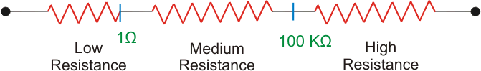[Resistance](https://www.electrical4u.com/electrical-resistance-and-laws-of-resistance/)s one of the most basic elements encountered in electrical and electronics engineering. The value of [resistance](https://www.electrical4u.com/electrical-resistance-and-laws-of-resistance/) in engineering varies from very small value like, resistance of a [transformer winding,](https://www.electrical4u.com/transformer-winding-resistance-measurement/) to very high values like, insulation resistance of that same [transformer](https://www.electrical4u.com/transformer-winding-resistance-measurement/) [winding.](https://www.electrical4u.com/transformer-winding-resistance-measurement/) Although a millimeter works quite well if we need a rough value of resistance, but for accurate values and that too at very low and very high values we need specific methods.

In this article we will discuss various methods of resistance measurement. For this purpose we categories the resistance into threeclasses-

# **2.2 MEASUREMENT OF LOW RESISTANCE (<1Ω)**

The major problem in **measurement of low resistance** values is the contact resistance or lead resistance of the measuring instruments, though being small in value is comparable to the resistance being measured and hence causes serious [error](https://www.electrical4u.com/errors-in-measurement-classification-of-errors/)

The methods employed for measurement of low resistances are:-

* Kelvin’s Double Bridge Method
* Potentiometer Method
* Ohmmeter.

# **2.2.1 KELVIN’S DOUBLE BRIDGE**

Kelvin’s double bridge is a modification of simple [Wheatstone bridge.](https://www.electrical4u.com/wheatstone-bridge-circuit-theory-and-principle/) Figure below shows the circuit diagram of [Kelvin’s double bridge.](https://www.electrical4u.com/kelvin-bridge-circuit-kelvin-double-bridge/)

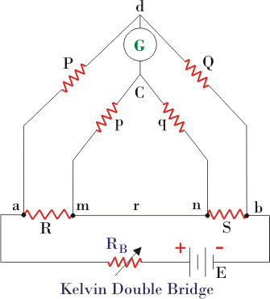

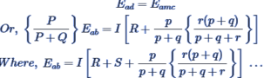 As we can see in the above figure there are two sets of arms, one with resistances P and Q and other with resistances p and q. R is the unknown low resistance and S is a standard resistance. Here r represents the contact resistance between the unknown resistance and the standard resistance, whose effect we need to eliminate. For measurement we make the ratio P/Q equal to p/q and hence a balanced [Wheatstone bridge](https://www.electrical4u.com/wheatstone-bridge-circuit-theory-and-principle/) is formed leading to null deflection in the galvanometer. Hence for a balanced bridge we can

Putting equation 2 in 1 and solving and using P/Q = p/q, we get-



Hence we see that by using balanced double arms we can eliminate the contact resistance completely and hence error due to it. To eliminate another error caused due to thermo-electric emf, we take another reading with[battery](https://www.electrical4u.com/battery-working-principle-of-batteries/) connection reversed and finally take average of the two readings. This bridge is useful for resistances in range of 0.1µΩ to 1.0Ω.

# **2.3 MEASUREMENT OF MEDIUM RESISTANCE (1Ω - 100KΩ)**

Following are the methods employed for measuring a resistance whose value is in the range 1Ω - 100kΩ .

* Ammeter-Voltmeter Method
* Wheatstone Bridge Method
* Substitution Method
* Carey- Foster Bridge Method
* Ohmmeter Method

# **2.3.1 WHEATSTONE BRIDGE METHOD**

This is the simplest and the most basic bridge circuit used in measurement studies. It mainly consists of four arms of resistance P, Q; R and S. R is the unknown resistance under experiment, while S is a standard resistance. P and Q are known as the ratio arms. An EMF source is connected between points a and b while a galvanometer is connected between points c and d

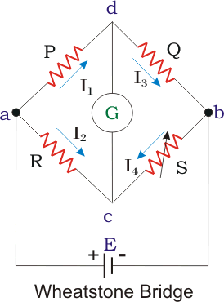

A bridge circuit always works on the principle of null detection, i.e.we vary a parameter until the detector shows zero and then use a mathematical relation to determine the unknown in terms of varying parameter and other constants. Here also

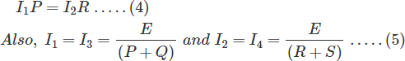

the standard resistance, S is varied in order to obtain null deflection in the galvanometer. This null deflection implies no current from point c to d, which implies that potential of point c and d is same.

Combining the above two equations we get the famous equation –

# **2.4 MEASUREMENT OF HIGH RESISTANCE (>100KΩ)**

Following are few methods used for measurement of high resistance values-

* Loss of Charge Method
* Megger Method
* Mega-ohm bridge Method
* Direct Deflection Method

# **2.4.1 LOSS OF CHARGE METHOD**

In this method we utilize the equation of voltage across a discharging [capacitor](https://www.electrical4u.com/what-is-capacitor-and-what-is-dielectric/) to find the value of unknown resistance R. Figure below shows the circuit diagram and the equations involved are-

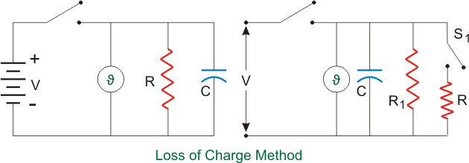

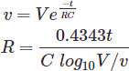

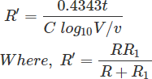However the above case assumes no leakage resistance of the capacitor. Hence to account for it we use the circuit shown in the figure below. R1 is the leakage resistance of C and R is the unknown resistance. We follow the same procedure but first with switch S1 closed and next with switch S1 open. For the first case we get

For second case with switch open we get

Using R1 from above equation in equation for R’ we can find R.

**AC BRIDGES:**

**2.5 GENERAL FORM OF A.C. BRIDGE:**

AC bridge are similar to D.C. bridge in topology (way of connecting).It consists of four arm AB,BC,CD and DA .Generally the impedance to be measured is connected between ‘A’ and ‘B’.A detector is connected between ‘B’ and ’D’. The detector is used as null deflection instrument. Some of the arms are variable element. By varying these elements, the potential values at ‘B’ and ‘D’ can be made equal. This is called balancing of the bridge

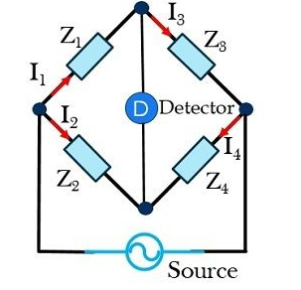General form of A.C. Bridge

At the balance condition, the current through detector is zero.

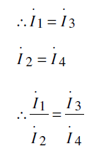

At balance condition,

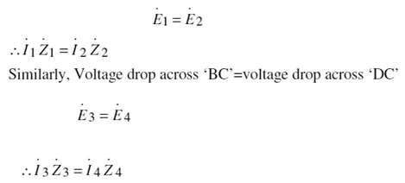Voltage drop across ‘AB’=voltage drop across ‘AD’.

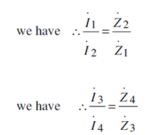

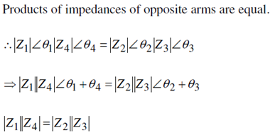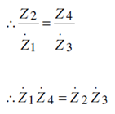

* For balance condition, magnitude on either side must be equal.
* Angle on either side must be equal

For balance condition

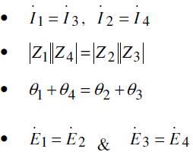

**TYPES OF DETECTOR:**

The following types of instruments are used as detector in A.C. Bridge.

* Vibration galvanometer
* Head phones (speaker)
* Tuned amplifier

**Vibration galvanometer:**

Between the point ‘B’ and ‘D’ a vibration galvanometer is connected to indicate the bridge balance condition. This A.C. galvanometer which works on the principle of resonance the A.C. galvanometer shows a dot, if the bridge is unbalanced.

**Head phones**

Two speakers are connected in parallel in this system. If the bridge is unbalanced, the speaker produced more sound energy. If the bridge is balanced, the speaker do not produced any sound energy

**Tuned amplifier:**

If the bridge is unbalanced the output of tuned amplifier is high. If the bridge is balanced, output of amplifier is zero.

**2.6 MAXWELL’S INDUCTANCE BRIDGE**

The choke for which R1 and L1 have to measure connected between the points ‘A’ and ‘B’. In this method the unknown inductance is measured by comparing it with the standard inductance.

L2 is adjusted, until the detector indicates zero current.

Let R1= unknown resistance

L1= unknown inductance of the choke.

L2= known standard inductance

R1, R2, R4= known resistances

Impedance of arm ab, Z1 = (R1+jwL1)

Impedance of arm cd, Z2 = R4

Impedance of arm ad, Z3 = (R2+r2+jwL2)

Impedance of arm bc, Z4 = R3

|  |  |
| --- | --- |
| **Figure: Maxwell’s inductance bridge** | **Phasor Diagram** |

Hence for balanced bridge,

Z1Z2 =Z3Z4

(R1+jwL1)xR4 = (R2+r2+jwL2)xR3

R1R4-R2R3-r2R3+jw(L1R4-L2R3) = 0

Equating real and imaginary part we get,

R1R4-R2R3-r2R3 = 0

R1R4 = R2R3+r2R3

= R3(R2+r2)

Hence, **R1 = (R3/R4)(R2+r2)**

and  (L1R4-L2R3) = 0

L1R4= L2R3

Hence,**L1= L2R3/ R4**

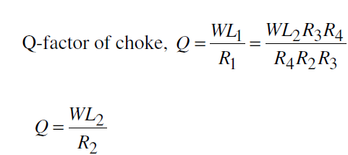Thus unknown inductance L1 and its resistance R1 may be calculated.

**Advantages:**

* Expression for R1 and L1 are simple.
* Equations area simple
* They do not depend on the frequency (as w is cancelled)
* R1 and L1 are independent of each other.

**Disadvantages:**

* Variable inductor is costly.
* Variable inductor is bulky.

**2.7 MAXWELL’S INDUCTANCE CAPACITANCE BRIDGE:**

In this method, Unknown inductance is measured by comparing it with standard capacitance. In this bridge, balance condition is achieved by varying ‘C4’

.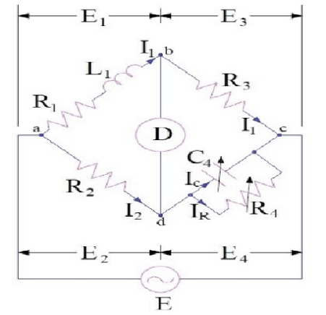

Fig 2.4 Maxwell’s inductance capacitance bridge

In the above diagram,

L1 = Unknown inductance with resistance R1

C4 =variable standard capacitor

R2, R3 & R4 = Known fixed resistance

Now,

Impedance of arm ab, Z1 = (R1+jwL1)

Impedance of arm cd, Z2 = R4 / (1+jwC4R4)

Impedance of arm ad, Z3 = R2

Impedance of arm bc, Z4 = R3

For bridge to be balance,

Z1Z2 =Z3Z4

(R1+jwL1)x [R4 / (1+jwC4R4)] = R2R3

R1R4-R2R3 +jw(L1R4-R2R3C4R4) = 0

Equating real and imaginary parts we get,

R1R4-R2R3 =0

**R1 = R2R3 / R4**

L1R4-R2R3C4R4 =0

**and L1 = R2R3C4**

The quality factor of inductor may also be calculated as

Q = wL1/R1

    = wR2R3C4 / R1

Since R4 = R2R3C4 / R1 ,

Hence**Q = wC4R4**

The phasor diagram of Maxwell Inductance Capacitance Bridge is shown below.

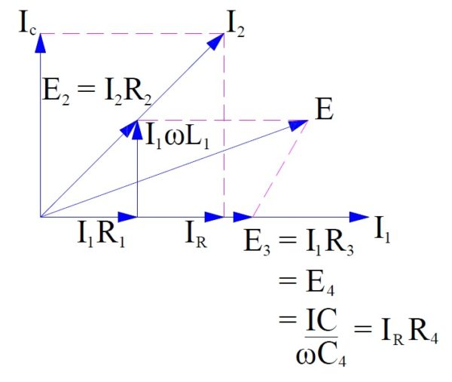

**Figure: Phasor diagram of Maxwell’s inductance capacitance bridge**

**Advantages:**

* Equation of L1 and R1 are simple.
* They are independent of frequency.
* They are independent of each other.
* Standard capacitor is much smaller in size than standard inductor.

**Disadvantages:**

* Standard variable capacitance is costly.
* It can be used for measurements of Q-factor in the ranges of 1 to 10.
* It cannot be used for measurements of choke with Q-factors more than 10.
* We know that Q =wC4R4

For measuring chokes with higher value of Q-factor, the value of C4 and R4 should be higher. Higher values of standard resistance are very expensive. Therefore this bridge cannot be used for higher value of Q-factor measurements.

**2.8 Hay’s bridge:**

Before we introduce **Hay’s bridge** let us recall the limitations of Maxwell bridge, in order to understand what is the necessity of **Hay’s Bridge Applications**. Maxwell bridge is only suitable for measuring medium quality factor coils however it is not suitable for measuring high quality factor (Q > 10). In order toto overcome from this limitation we need to do modification in Maxwell bridge so that it will become suitable for measuring Q factor over a wide range. This modified Maxwell bridge is known as Hay’s bridge.

In this bridge the electrical resistance is connected in series with the standard capacitor. Here l1 is unknown inductor connected in series with resistance r1. c4 is standard capacitor and r2, r3, r4 are pure electrical resistance forming other arms of the bridge.

|  |  |
| --- | --- |
| Construction-of-Hays-Bridge **Figure: Hay’s bridge** | Phasor-Diagram **Figure: Phasor diagram of Hay’s bridge** |

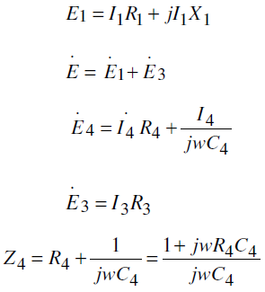





(*R*1 *jwL*1)(1*jwR*4*C*4 ) *jwR*2*C*4 *R*3

R1 jwC4 R4 R1 jwL1  j 2w2 L1C4 R4 jwC4 R2 R3



Comparing the real term and imaginary terms

R1R4+(L1/C4) = R2*R3

jωL1R4-(jR1/ωc4) = R2*R3

By solving the above equations we can get

L1 = R2R3C4/(1+ ω2R42C42)

R1= ω2C42R2R3R4/ω2R42C42

The QF of the coil is

Q = ωL1/R1 = 1/ ω2R4C4

The unknown capacitance & inductance equation mainly includes frequency term. Therefore to find the unknown inductance value, the supply frequency must be known.

Q = 1/ ω2R4C4

**Advantages:**

* Fixed capacitor is cheaper than variable capacitor.
* This bridge is best suitable for measuring high value of Q-factor.

**Disadvantages:**

* Equations of L1and R1 are complicated.
* Measurements of R1 and L1 require the value of frequency.
* This bridge cannot be used for measuring low Q- factor

**OWEN’S BRIDGE:**

We have various bridges to measure inductor and thus quality factor, like Hay’s bridge is highly suitable for the measurement of quality factor greater than 10, Maxwell’s bridge is highly suitable for measuring medium quality factor ranging from 1 to 10 and Anderson bridge can be successfully used to measure inductor ranging from few micro Henry to several Henry. So what is the need of **Owen’s Bridge**?.  
The answer to this question is very easy. We need a bridge which can measure inductor over wide range. The bridge circuit which can do that, is known as Owen’s bridge. It is AC bridge just like Hay’s bridge and Maxwell bridge which use standard capacitor, inductor and variable resistors connected with AC source for excitation.

The AC supply is connected at a and c point.

The arm ab is having inductor having some finite resistance let us mark them r1 and l1. The arm bc consists of pure [electrical resistance](https://www.electrical4u.com/what-is-electrical-resistance/) marked by r3 as shown in the figure given below and carrying the current i1 at balance point which is same as the [current](https://www.electrical4u.com/electric-current-and-theory-of-electricity/) carried by arm ab.  
The arm cd consists of pure capacitor having no electrical résistance. The arm ad is having variable resistance as well as variable capacitor and the detector is connected between b and d. Now how this bridge works? this bridge measures the inductor in terms of capacitance. Let us derive an expression for inductor for this bridge.

|  |  |
| --- | --- |
| Figure: Owen’s bridge | Figure:Phasor diagram of Owen’s bridge |

Here l1 is unknown [inductance](https://www.electrical4u.com/what-is-inductor-and-inductance-theory-of-inductor/) and c2 is variable standard capacitor.

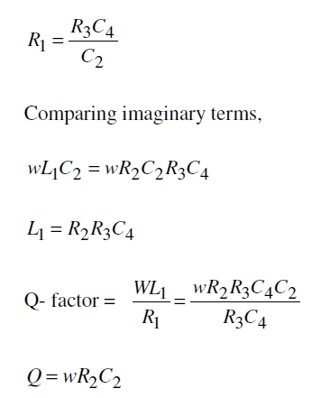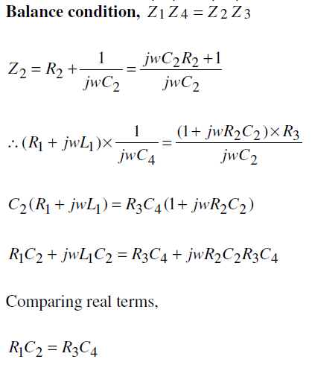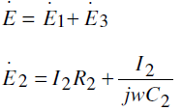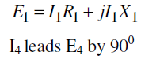

**Advantages:**

* Expression for R1 and L1 are simple.
* R1 and L1 are independent of Frequency.

**Disadvantages:**

* The Circuits used two capacitors.
* Variable capacitor is costly.
* Q-factor range is restricted
  1. **Anderson’s bridge:**

we have Maxwell bridge and Hay’s bridge to measure quality factor of the circuit. The main disadvantage of using Hay’s bridge and Maxwell bridge is that, they are unsuitable of measuring the low quality factor. However Hay’s bridge and Maxwell bridge are suitable for measuring accurately high and medium quality factor respectively. So, there is need of bridge which can measure low quality factor and this bridge is modified Maxwell’s bridge and known as **Anderson’s bridge**.  
Actually this bridge is the modified Maxwell inductor capacitance bridge. In this bridge double balance can obtained by fixing the value of capacitance and changing the value of electrical resistance only.

It is well known for its accuracy of measuring inductor from few micro Henry to several Henry. The unknown value of self inductor is measured by method of comparison of known value of electrical resistance and capacitance. Let us consider the actual **circuit diagram of Anderson’s bridge**.

In this circuit the unknown inductor is connected between the point a and b with electrical resistance r1 (which is pure resistive). The arms bc, cd and da consist of resistances r3, r4 and r2 respectively which are purely resistive. A standard [capacitor](https://www.electrical4u.com/what-is-capacitor/) is connected in series with variable electrical resistance r and this combination is connected in parallel with cd. A supply is connected between b and e.

|  |  |
| --- | --- |
| Figure:Anderson’s bridge | Figure:Phasor diagram of Anderson’s bridge |

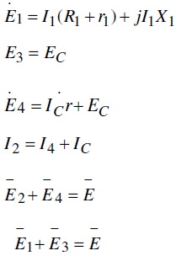

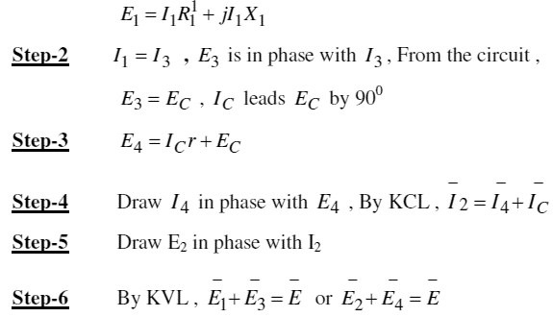**Step-1**Take I1 as references vector .DrawI1R1 in phase with I1

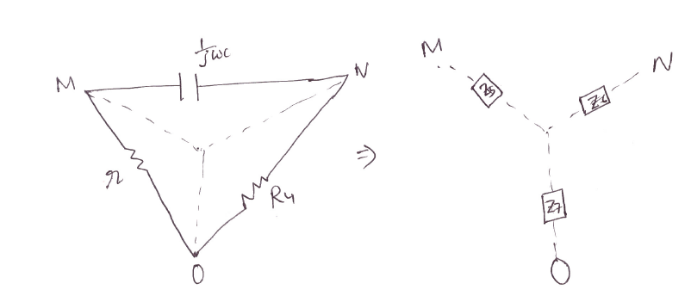

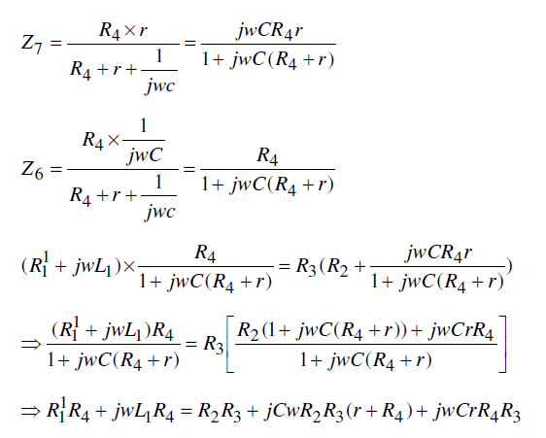**Equivalent delta to star conversion for the loop MON**

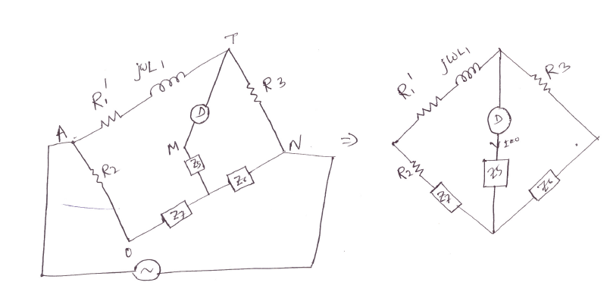

**Simplified diagram of Anderson’s bridge**

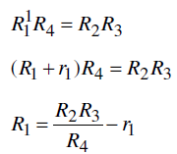Comparing real term,

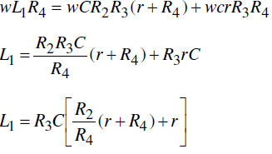Comparing the imaginary term,

**Advantages:**

* Variable capacitor is not required.
* Inductance can be measured accurately.
* R1 and L1 are independent of frequency.
* Accuracy is better than other bridges

**Disadvantages:**

* Expression for R1 and L1 are complicated.
* This is not in the standard form A.C. bridge

**2.10 MEASUREMENT OF CAPACITANCE AND LOSS ANGLE (DISSIPATION FACTOR):**

**Dissipation factors (D):**

A practical capacitor is represented as the series combination of small resistance and ideal capacitance. From the vector diagram, it can be seen that the angle between voltage and current is slightly less than 900. The angle‘d’ is called loss angle.

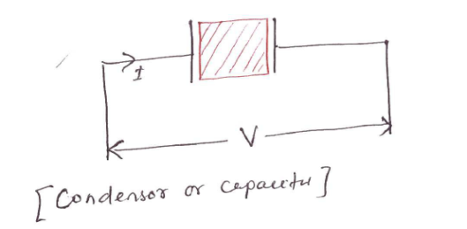

**Condensor or capacitor**

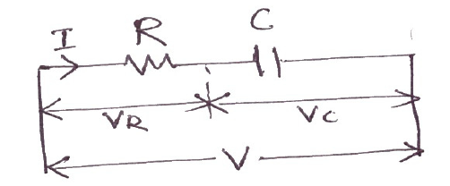

**Representation of a practical capacitor**

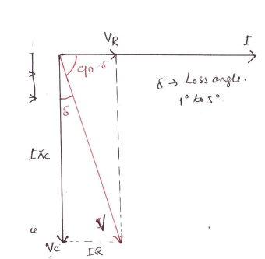

**Vector diagram for a practical capacitor**

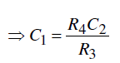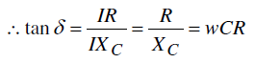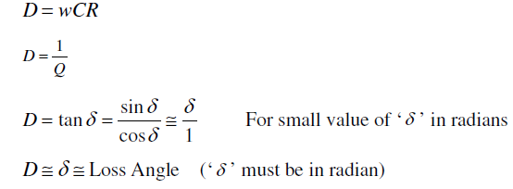 A dissipation factor is defined as ‘tanδ’.

**DESAUTY’S BRIDGE:**

DeSauty’s bridge is the simplest method of comparing two capacitances.The connections and the phasor diagram of DeSauty’s Bridge are shown in the below figure

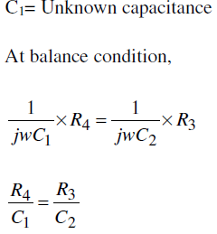

|  |  |  |
| --- | --- | --- |
| **Figure:Desauty’s bridge** | | **Figure:Phasor diagram** |
|  |  | | |

**2.11 SCHERING BRIDGE:**

This bridge is used to measure to the [capacitance](https://www.electrical4u.com/what-is-capacitor/) of the capacitor, dissipation factor and measurement of relative permittivity. Let us consider the circuit of **Schering bridge** as shown below:

E1 = I1r1 − jI1X4

C2 = C4= Standard capacitor (Internal resistance=0)

C4= Variable capacitance.

C1= Unknown capacitance.

r1= Unknown series equivalent resistance of the capacitor

R3=R4= Known resistor

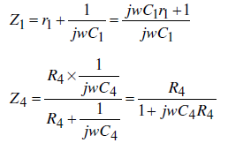

|  |  |
| --- | --- |
| **Figure:Schering Bridge** | **Figure:Phasor diagram of Schering Bridge** |

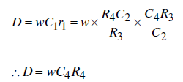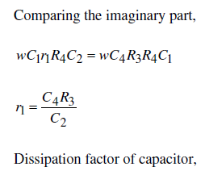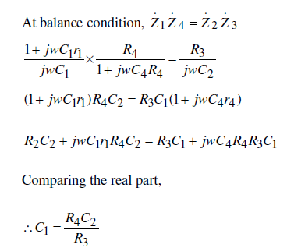**Advantages:**

* In this type of bridge, the value of capacitance can be measured accurately.
* It can measure capacitance value over a wide range.
* It can measure dissipation factor accurately.

**Disadvantages**

* It requires two capacitors.
* Variable standard capacitor is costly.

**2.12 MEASUREMENTS OF FREQUENCY(WEIN’S BRIDGE):**

Wien Bridge Circuit DiagramWien Bridge Circuit DiagramWein’s bridge is popularly used for measurements of frequency of frequency. In this bridge, the values of all parameters are known. The source whose frequency has to measure is connected as shown in the figure.

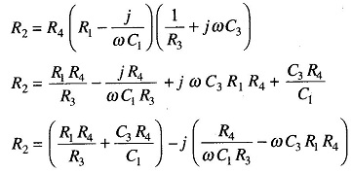**Wien Bridge Circuit Diagram**At balance condition

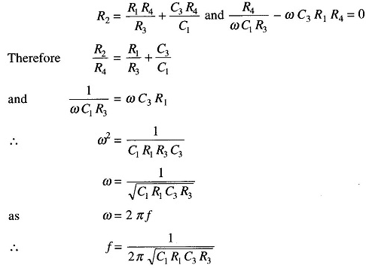Equating the real and imaginary terms we have

|  |  |
| --- | --- |
| Figure: Wein’s bridge | Figure: Phasor diagram of Wein’s bridge |

The above bridge can be used for measurements of capacitance. In such case, r1 and C1 are unknown and frequency is known. By equating real terms, we will get R1 and C1. Similarly by equating imaginary term, we will get another equation in terms of r1 and C1. It is only used for measurements of Audio frequency.

A.F=20 HZ to 20 KHZ

R.F=>> 20 KHZ

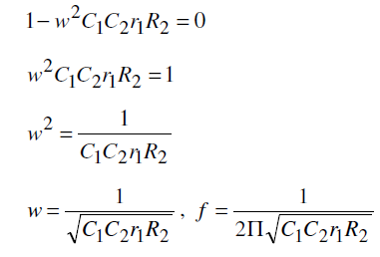 Comparing real term

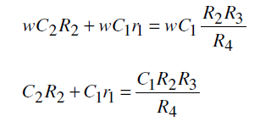

**9. Practice Quiz**

**1. Who invented the Wheatstone bridge?**

**a) Samuel Hunter Christie**  
b) Sir Charles Wheatstone  
c) Joseph henry  
d) Andrew Kay

**2. In a Wheatstone bridge, which of the following is used as a null detector?**a) Ammeter  
**b) Galvanometer**  
c) Voltmeter  
d) Wattmeter

**3. Which of the following device is used for measuring low resistance value?**a) Wheatstone bridge  
b) Hay bridge  
**c) Kelvin bridge**  
d) Owens bridge  
**4. Accuracy in a bridge measurement depends on_____________**  
a) Sensitivity of detector  
b) Applied voltage  
**c) Both Sensitivity and applied voltage**  
d) Accuracy of indicator  
**5. Given a Wheatstone-bridge with external voltage V, Resistance Bridge with resistances P, Q, R, S, and galvanometer G. What is the balancing condition of**

B**ridge?**  
[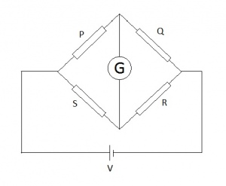](https://www.sanfoundry.com/wp-content/uploads/2017/05/instrumentation-transducers-question-answers-resistance-measurement-q1.png)

**a) P⁄Q=S⁄R**  
b) P⁄S=R⁄Q  
c) P = R⁄Q  
d) S = R⁄Q

**6. Measurement of impedance involves calculating ______________**a) Resistive component of impedance  
b) Reactive component of impedance  
**c) Both resistive and reactive component of impedance**d) None of the mentioned  
**7. What is the purpose of Owens Bridge?**a) Measurement of resistance  
b) Measurement of current  
**c) Measurement of reactance**  
d) Measurement of voltage

**8. Which of the following range represents the quality factor of Owens Bridge?**a) Less than 1  
b) 1 to 10  
**c) Very high**  
d) Negligible.

**9. Bridge circuits are used for the measurement of**  
A. Resistance  
B. Inductance  
C. Capacitance  
**D. All of these**  
**10. Low resistance is the resistance of the order of**  
**A. 1 ohm and less than 1 ohm**B. 1 ohm to 1 mega ohm  
C. More than one ohm  
D. None of these  
**11. AC bridges are used for the measurement of**  
A. Resistances  
B. Resistances and Inductances  
**C. Inductances and capacitances**  
D. Resistances, inductances, and capacitance

**12. The commonly used detectors in ac bridges is/are**

A. Headphones  
B. Vibration galvanometers  
C. Tuned amplifiers, headphones  
**D. Head phones, tuned amplifiers, vibration galvanometers**  
**13. The Ac Bridge used for the measurement of inductance is/are**

A. Maxwell’s inductance bridge  
B. Hay’s bridge  
C. Anderson’s bridge, Owen’s bridge  
**D. All of these**

**14. Under balanced condition, the current flowing through the detector is equal to**  
A. 1 A  
**B. 0 A**  
C. Sum of the currents flowing in the adjacent arms  
D. Difference between the current flowing in the adjacent arms

**15. In Maxwell’s Inductance-Capacitance bridge, the frequency ω**  
A. Is directly proportional to the inductance in the balanced equation  
B. Is inversely proportional to the capacitance in the balanced equation  
C. Is directly proportional to the product of inductance and capacitance  
**D. Does not appear in the balanced equations**  
**16. If C4 is the capacitance and R4 is the resistance of Hay’s bridge, then the Q factor of Hay’s bridge is given by**  
**A. 1 / ωC4R4**  
B. ωC4R4  
C. ωC4 / R4  
D. ωR4 / C4  
**17. The Hay’s bridge is suitable for the measurement of inductances of coils with Q factor**  
**A. More than 10**  
B. Less than 1  
C. More than 1  
D. Less than 10  
**18. Anderson bridges is suitable for the measurement of**  
A. Resistance  
**B. Inductance**  
C. Capacitance  
D. All of these  
**19. The Schering bridges can be used at**  
A. low voltage  
B. high voltage  
C. medium voltage  
**D. both (a) and (b)**  
**20. Schering bridges are used for the measurement of**  
A. Unknown capacitance  
B. Dielectric loss  
C. Power factor  
**D. All of these**

**10. Assignments**

|  |  |  |  |
| --- | --- | --- | --- |
| **S.No** | **Question** | **BL** | **CO** |
| 1 | Draw the Kelvin’s double bridge circuit and explain the measurement of low resistance using this bridge. | **1** | **4** |
| 2 | Describe in brief about the loss of charge method of measurement of high resistance. | **2** | **2** |
| 3 | With a neat phasor diagram, explain how capacitance of an unknown capacitor can be determined using Schering bridge. | **2** | **4** |
| 4 | What type of bridge can be used for the measurement of dielectric of insulating oil used intrans formers? Justify. | **2** | **1** |
| 5 | With neat circuit diagram ,explain about wheat stone Bridge | **2** | **4** |

1. **Part A- Question & Answers**

|  |  |  |  |
| --- | --- | --- | --- |
| S.No | Question & Answers | BL | CO |
| 1 | **What is the range of low, medium and High resistance?**  Ans: i) All resistances of the order of 1 ohm and under may be classified as low resistances.  ii) All resistances of the order of 1 ohm upwards to about 0.1 M Ohm are classified as medium resistances.  iii) All resistances of the order of 0.1 MOhm and upwards may be classified as high resistances | **1** | **1** |
| 2 | **What are the various methods to measure low resistance? why Kelvin’s double bridge is preferred among all?**  Ans: Low resistance can be measured by using i) ammeter voltmeter method ii) Kelvin’s double bridge method iii)potentiometer method. Among all Kelvin’s double bridge method is preferred in which the contact resistances and lead resistances can be eliminated by proper design. | **1** | **1** |
| 3 | **Define the sensitivity of Wheatstone bridge? what are the sources of errors in wheatstone bridge?**  Ans: Bridge sensitivity is defined as the deflection of the galvanometer per unit fractional change in unknown resistance. the various sources of measurement errors are i) errors due to resistance of leads and contacts ii) insufficient sensitivity of the null detector iii)changes in resistance of the bridge arms due to heating effect of the current through the resistors. | **1** | **1** |
| 4 | **Define high resistance with one example and list out the methods to measure it?**  Ans: Resistances of the order of 100Kohm and upwards are classified as high resistances. insulation resistance of a cable is one of the example for high resistance, high resistance can be measured by loss of charge method, megohm method, megger | **1** | **1** |
| 5 | **When a bridge is said to be balance? what are the balance conditions in an AC bridge?**  Ans: A bridge is said to be balanced when there is no deflection in the detector, there are two balance conditions exist in an AC bridge namely magnitude condition and phase condition. | **1** | **1** |
| 6 | **Define Q factor? what is meant by low Q coils and high Q coils?**  Ans: Q factor is defined as the ratio between power stored in the coil to the power dissipated in the coil. The value of Q>10 are known as high Q coils and the value of Q in between 1 and 10 are known as low Q coils. | **1** | **1** |
| 7 | **What are the advantages of hays bridge? (or) which bridge is suitable for measurement of inductance of high Qcoils? why?**  Ans: Hays bridge is suitable for coils having Q>10. If we examine the expression for Q factor it is clear that for high Q coils the bridge requires only a low resistor . | **2** | **1** |
| 8 | **What are tha advantages and disadvantages of andersons bridge?**  Ans: i)a fixed capacitor can be used instead of a variable capacitor  ii)this bridge may be used for accurate determination of capacitance in termsof inductance  the disadvantages are i)more complex bridge  ii)the difficulty of shielding the bridge | **2** | **1** |
| 9 | **What are the Disadvantages of Maxwell Bridge?**  Ans: the Disadvantages of Maxwell Bridge are:  1. This bridge requires a variable standard capacitor which may be very expensive if calibrated to a high degree of accuracy.  2. The bridge is limited to measurement of low Q coils. | **2** | **1** |
| 10 | **What are the types of sources and detectors in bridges?**  Ans: For measurement at low frequencies the power line may act as the source of supply to the bridge circuits. For higher frequencies electronic oscillators are the sources.  The detectors are normally head phones, vibration galvanometers, tunable amplifiers  3. The Maxwell’s inductance-capacitance bridge is very useful for measurement of a wide range of inductance power and audio frequency. | **2** | **1** |

1. **Part B- Questions**

|  |  |  |  |
| --- | --- | --- | --- |
| **S.No** | **Question** | **BL** | **CO** |
| 1 | Explain how the inductance is measured in terms of known capacitance using Maxwell’s bridge. | **1** | **4** |
| 2 | Explain how an unknown resistance can be measured by wheat stone bridge.. | **2** | **4** |
| 3 | With the help of circuit diagram, explain how capacitance can be measured by the use of a Schering bridge. | **1** | **4** |
| 4 | With the help of circuit diagram explain how low resistance can be measured by using Kelvin double bridge. | **2** | **4** |
| 5 | The value of a high resistance is measured by loss of charge method. A capacitor having a capacitance of is charged to a potential of 500 V D.C and is discharged through the high  resistance. An electrostatic voltmeter, kept across the high resistance, reads the voltage as 300 V at  the end of 60 seconds. Calculate the value of high resistance. | **2** | **4** |

1. **Supportive Online Certification Courses**

1.Electrical Measurement and electronics instruments By Prof. **Avishek Chatterjee**, IIT Kharagpur – 12 weeks conducted by NPTEL

2.Electrical Measuremernts&instrumrntation course conducted by Udemy

3.Online course on Electrical measurements by Dupont elearning suit

4.Online Electrical Training course on electrical measuring instruments by TPC Training

1. **Real Time Applications**

|  |  |  |
| --- | --- | --- |
| S.No | Application | CO |
| 1 | Strain Measurement using wheatstone Bridge | **1** |
| 2 | **Maxwell’s Bridge used in** communication systems and power and audio frequency circuits | **1** |
| 3 | **Schering bridge used in generator,power engines and used in house industrial networks** | **1** |

1. **Contents Beyond the Syllabus**
2. Ammeter-Voltmeter method for resistance measurement
3. Megger for high reisistance measurement
4. Campbell’s bridge and Heaviside Bridge to measure mutual inductance
5. **Prescribed Text Books& Reference Books**

|  |
| --- |
| **Text Books:** |
| 1. A K Sawhney, “Electrical and Electronic measurement and instruments”, Dhanpat Rai and Sons Publications.  2. E W Golding and F C Widdis, “Electrical measurements and measuring instruments” wheeler publishing. 5th Edition.  3. J.B. Gupta “A Course in Electrical and Electronic Measurements & Instrumentation” SK Kataria and Son’s, 14th Edition |
| **Reference Books:** |
| 1. Buckingham and Price, “Electrical measurements”, Prentice Hall.  2. D V S Murthy, “Transducers and Instrumentation”, Prentice Hall of India, 2nd Edition, 2009.  3. A S Morris, “Principles of measurement of instrumentation”, Pearson/Prentice Hall of India, 2nd Edition, 1994.  4. H S Kalsi, “Electronic Instrumentation”, Tata McGrawHill Edition, 1st Edition 1995. |
| **Web References:** |
| 1. https://www.researchgate.net  2. https://www.aar.faculty.asu.edu/classes/  3. https://www.electrical4u.com  4.https://efficientcarbon.com/wp-content/uploads/2013/07/Net-Metering-and-Solar-Rooftop_Whitepaper_EfficientCarbon.pdf  5. https://www.conserve-energy-future.com/what-is-net-metering-and-how-net-metering-works.php |
| **E-Text Books:** |
| 1. https://www.jntubook.com  2. https://www.freeengineeringbooks.com  3. https://www.bookboon.com/en/mechanics |

1. **Mini Project Suggestion**

**1.Wheatstone Bridge Light Detector**

Balanced bridge circuits find many useful electronics applications such as being used to measure changes in light intensity, pressure or strain. The types of resistive sensors that can be used within a wheatstone bridge circuit include: photoresistive sensors (LDR’s), positional sensors (potentiometers), piezoresistive sensors (strain gauges) and temperature sensors (thermistor’s), etc.

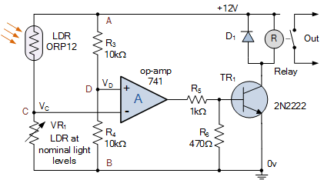

### 2.**The Wien bridge oscillator:**

The circuit of a Wien bridge oscillator is shown in Figure 11.3. It uses a series and a parallel RC circuit connected as a potential divider to provide frequency dependent phase shift. The phase shift between the input and the output of the network is zero at one particular frequency. This property can be exploited to make an oscillator. Note that the feedback is applied to the non-inverting input of the amplifier.

